# PEER EVALUTION - **BROCHURE**

YOUR NAME: ___Chhun senghak____________________________

THE STUDENT YOU ARE EVALUATING: ____Moeun Chandy___________________________

To submit:

* + You will need to **analyse 1 brochure**
  + **Please include the brochure in this doc**
  + Complete this document
  + Submit you work on Google classroom

**BROCHURE**

Include here the brochure you are analysing

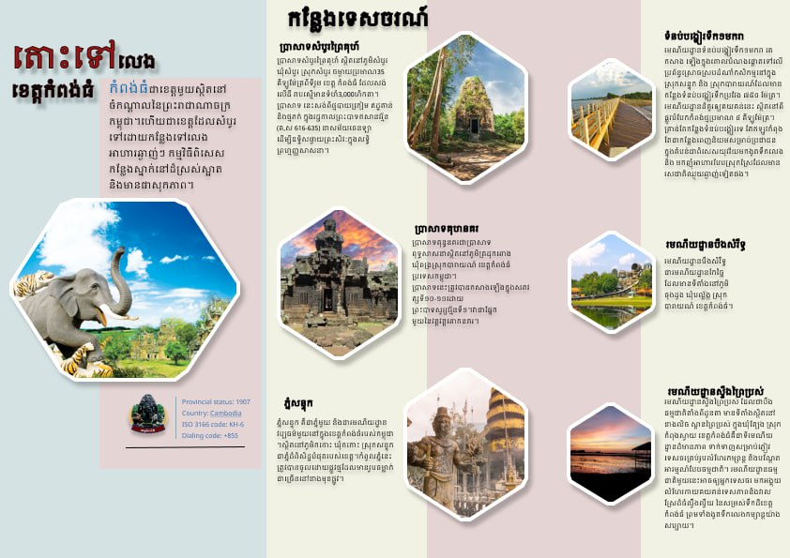

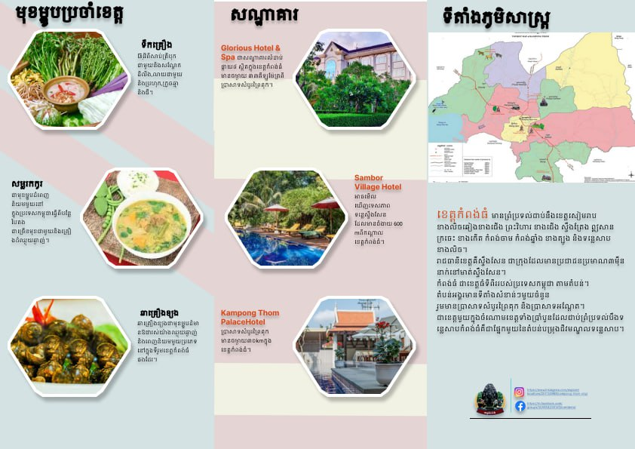

**EVALAUTION GRID**

|  |  |  |
| --- | --- | --- |
| CATEGORY | CRITERIA | EXAMPLE OF ANALYSIS |
| **FONT** | The **fonts**, the **font size**, and style are well selected and create a visual **interest** | The design uses a bold and eye-catching font for the event title. The font size is good because the font title, font main point, and font body text are good for reading. And no more than three fonts are used. |
| **COLOR** | The **color palette** is well selected and create a visual **interest** | The design uses a colour scheme that complements the school colours and creates visual interest. |
| **COMPOSITION** | The layout of the design well-organized and **easy to follow**, with a clear **hierarchy** of information | The layout of the design is well organised and easy to follow, with a clear hierarchy of information. The use of space and alignment helps to create a clean and professional look.It's good to follow. |
| **CONTRAST** | Is there sufficient **contrast** between the different elements of the design to **make them stand out** and create visual interest | The use of contrast in the design is good because it has title contrast and a picture. Especially the main point should be bold. |
| **BALANCE** | Is the design **balanced** in terms of its use of space, text, and graphics | The design is well-balanced in terms of its use of space, text, graphics, and alignment.  The event information is clearly presented and does not feel cluttered. |
| **PROXIMITY** | Are related elements of the design **grouped** together to create **visual unity** and **hierarchy** | The related elements of the design are grouped together effectively, with the event title, date, and location presented in a clear and organised manner. Picture and body are related and are put together too. |
| **REPETITION** | Is there consistent use of design elements (such as fonts, colors, and graphics) throughout the design to **create visual unity** | The design is good because it has alignment left, the same font body, repeat size of font, repeat colour, and bold. |
| **WHITE SPACE** | Is there sufficient white space (or negative space) in the design to create **visual breathing room** and balance | The design makes good use of white space to create visual breathing room and balance.  It has groups of content, so it has white space. that makes it good for viusal. |

**FINAL ANALYSIS**

What are the **good points** of this design? (*Details as much as possible)*

For me, I think this design have alots good points because:

* Font: Have two font styles.
* Font colours have three colours: blue, red, and black.
* Repetition is good because the picture size has repetition. Bold on the main point.
* It is very useful to have a picture for contrast.
* The part of food that has groups

What could be **improved**? *(Details as much as possible)*

For me, it could improve the colour background because it is hard to see.